Derek McCrea's April 2008 Artist Newsletter

I have been very busy this month painting tropical images and bird paintings.

I have attached below the images I have created during the month of April.

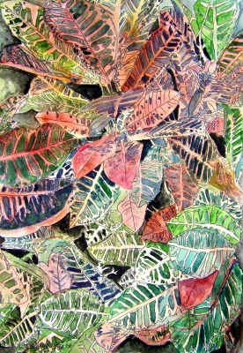

Croton Painting 12 x 16 inches realistic watercolor tropical plant painting. Available as a limited edition print or the original at http://www.derekmccrea.50megs.com/photo.html

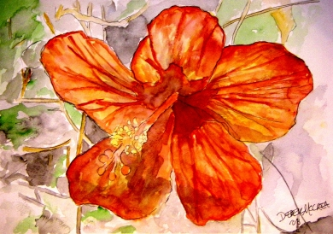

Hibiscus 2 Painting 12 x 16 inches realistic watercolor tropical plant painting. Available as a limited edition print or the original at http://www.derekmccrea.50megs.com/photo.html

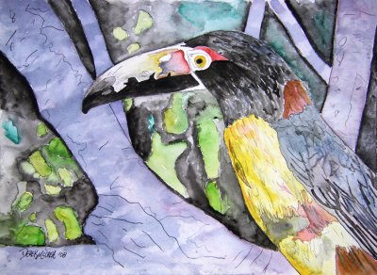

Toucan Painting 12 x 16 inches realistic watercolor tropical wildlife painting. Available as a limited edition print or the original at http://www.derekmccrea.50megs.com/pelicans_birds.html

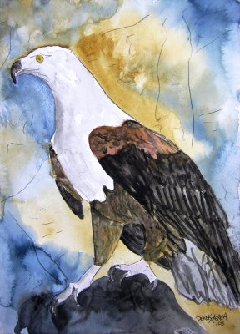

Eagle Painting 12 x 16 inches realistic watercolor tropical wildlife painting. Available as a limited edition print or the original at http://www.derekmccrea.50megs.com/pelicans_birds.html

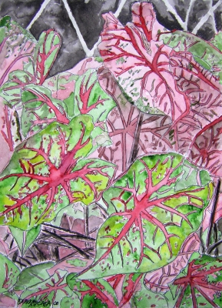
Caladiums Painting 12 x 16 inches realistic watercolor tropical painting. Available as a limited edition print or the original at http://www.derekmccrea.50megs.com/photo.html

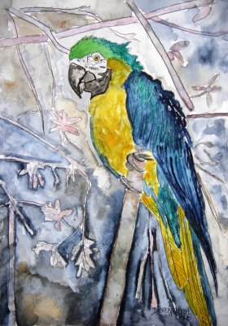

Parrot Painting 12 x 16 inches realistic watercolor tropical wildlife painting. Available as a limited edition print or the original at http://www.derekmccrea.50megs.com/pelicans_birds.html

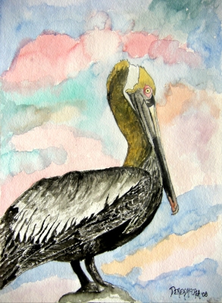

pelican 2 Painting 12 x 16 inches realistic watercolor tropical wildlife painting. Available as a limited edition print or the original at http://www.derekmccrea.50megs.com/pelicans_birds.html

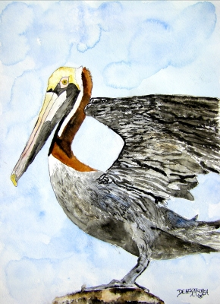

pelican 4 Painting 12 x 16 inches realistic watercolor tropical wildlife painting. Available as a limited edition print or the original at http://www.derekmccrea.50megs.com/pelicans_birds.html

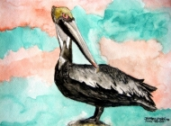
Pelican 3 Painting 12 x 16 inches realistic watercolor tropical wildlife painting. Available as a limited edition print or the original at http://www.derekmccrea.50megs.com/pelicans_birds.html

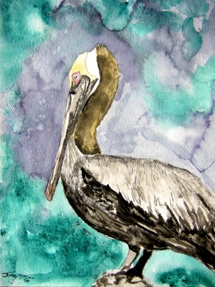
pelican Painting 12 x 16 inches realistic watercolor tropical wildlife painting. This is my sons first watercolor, after years of lessons from me with oils, etc, we sat down and he finished this, it made me proud. Available as a limited edition print or the original at http://www.derekmccrea.50megs.com/pelicans_birds.html

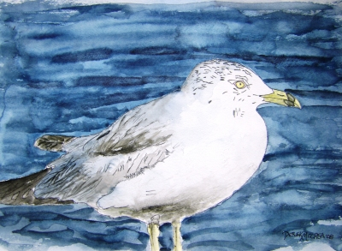

Seagull Painting 12 x 16 inches realistic watercolor tropical wildlife painting. Available as a limited edition print or the original at http://www.derekmccrea.50megs.com/pelicans_birds.html

Any painting you see on my online gallery can be turned into a mural tile. For example if wish to have a backsplash fora kitchen made select any image on my site and let me know what size you would like the backsplash, or bathroom mural. I am the featured artist of the below Canadian Company that makes tiles.

http://www.thermodigital.com/DetailsWorks_A.html

I have been busy painting and will keep it up take a look at my gallery if you get the time at

http://www.derekmccrea.50megs.com/

I am trying to complete a painting a day and have for the last several weeks. To get a daily update on completed works visit my blog below, enter your email address in the block provided under "subscribe to my art newsletter" It is a daily event unlike this newsletter which is a monthly summary.

http://watercolorpaintingart.blogspot.com/



